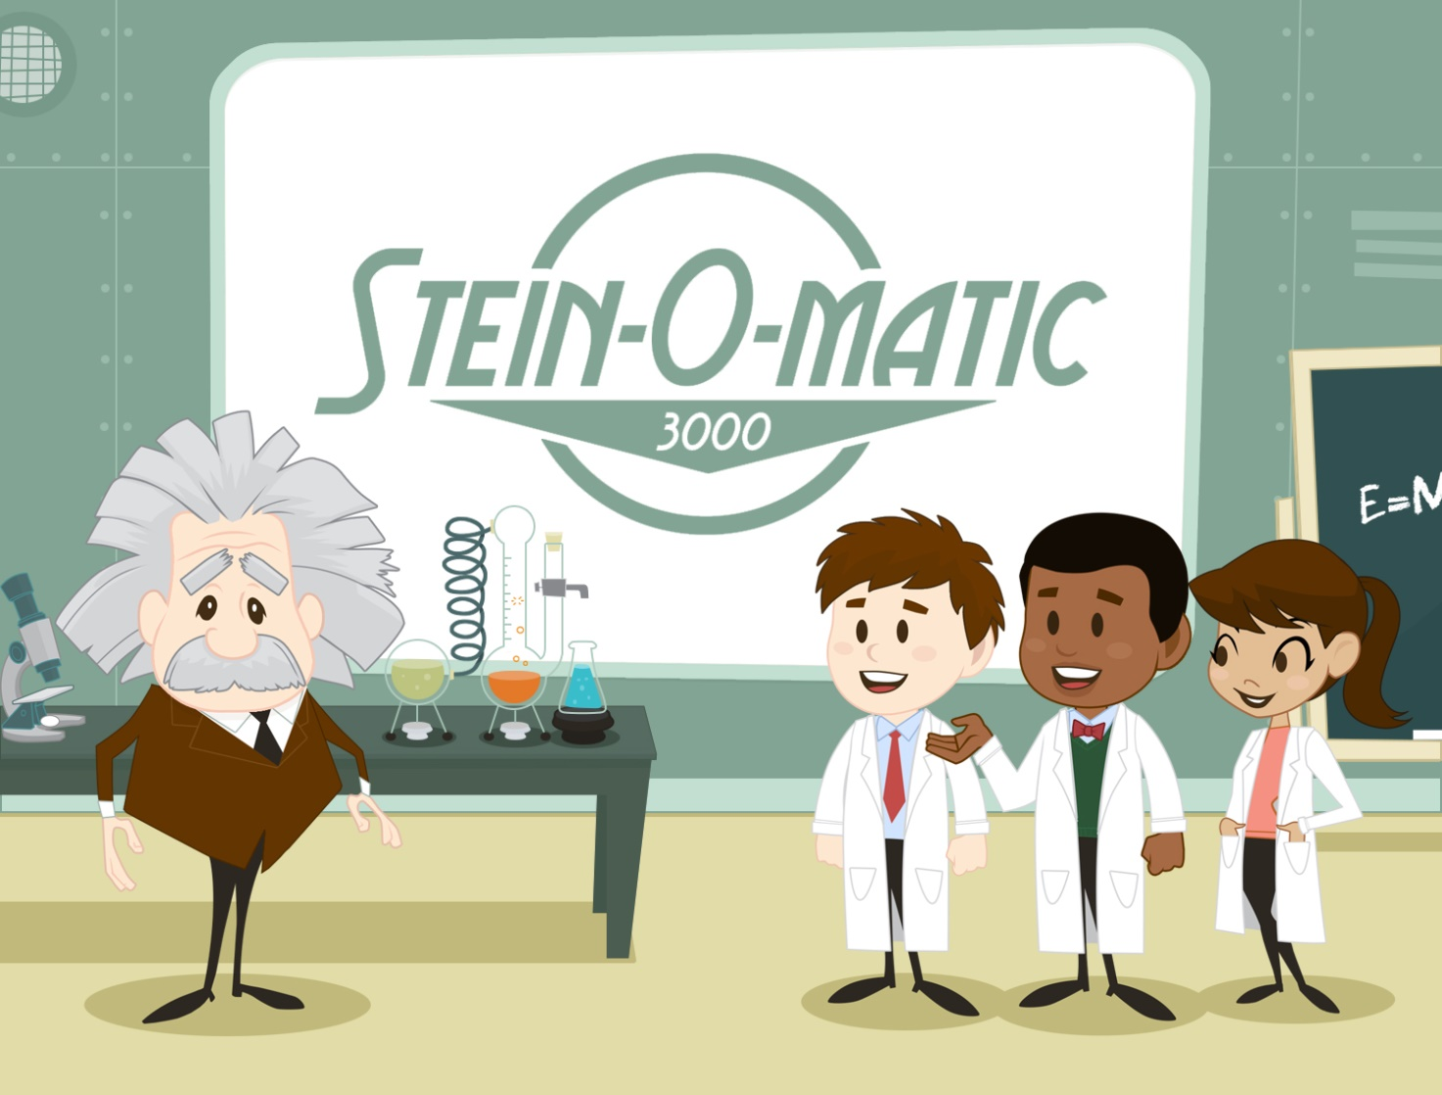

Art Design Document

For

Einstein “Stein-O-Matic 3000” Companion App

**February 26th, 2016**

**Table of Contents**

1 Creative Direction 3

1.1 Executive Summary 3

2 Detailed Design 4

2.1 Avatar Design 4

3 Interface Design 6

3.1 Icons and Buttons 6

3.2 Games and Apps 7

3.3 Fonts 11

4 Color Scheme 12

5 Form Language 12

6 Misc. 13

# Creative Direction

## Executive Summary

The Stein-O-Matic 3000 app will incorporate the shapes, style and tone of yesteryear and combine it with the flare and feedback of a modern app. The app acts as a supplement to the interaction the player with have with the robot. Our goal is to have an immersive stylistic environment in which the user can immediately recognize as the ‘Stein-O-Matic’ Brand.

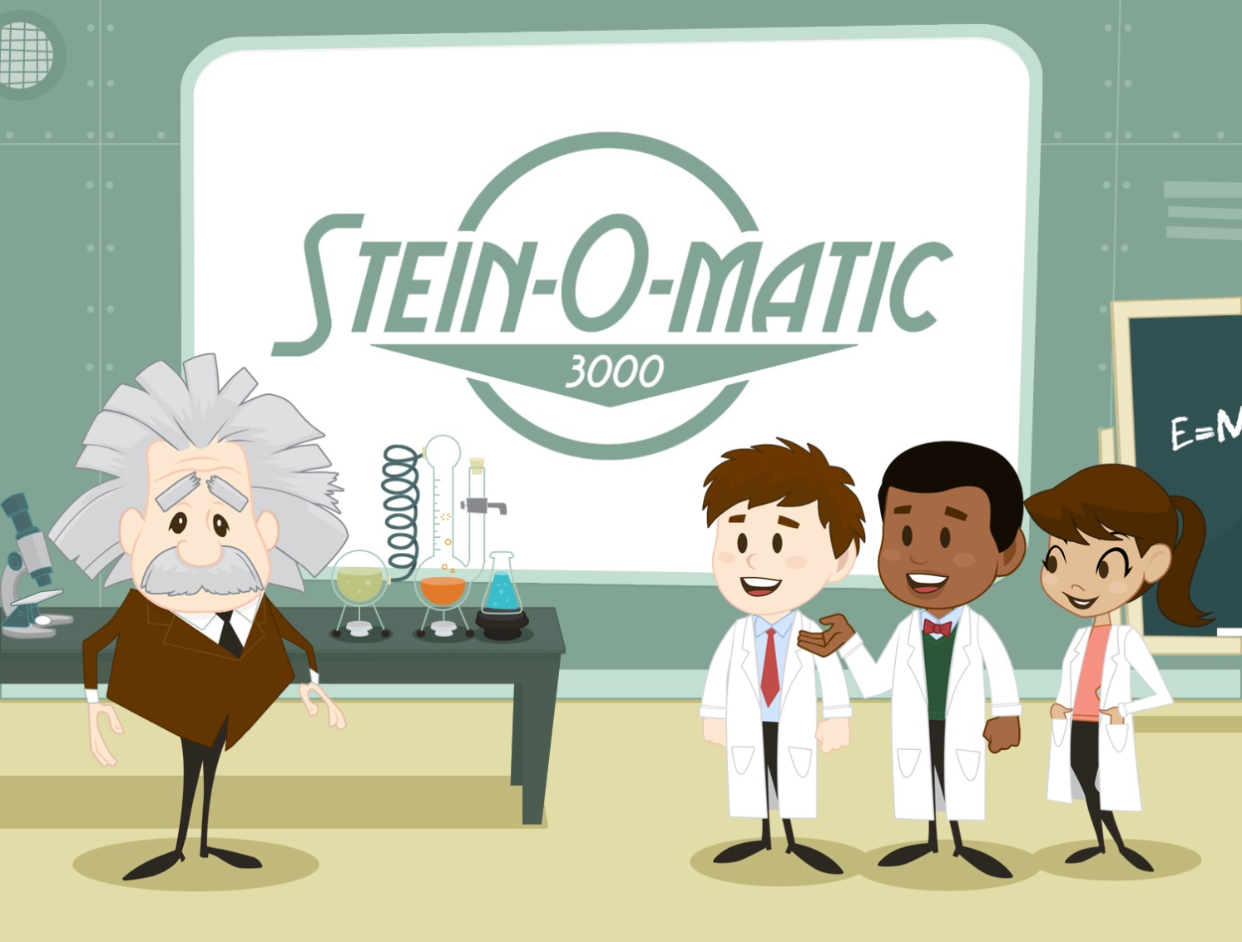

# Detailed Design

## Avatar Design

Avatars will have the same “mid-century” style of the icons and interface, and will have many races and genders.



Each player will be able to customize their avatar, gaining unlockable add ons as they complete parts of the app. These include things like hairstyles, mustaches, goggles, new coats, etc.



We have a preliminary concept of Einstein himself, for whenever his avatar appears in the app.

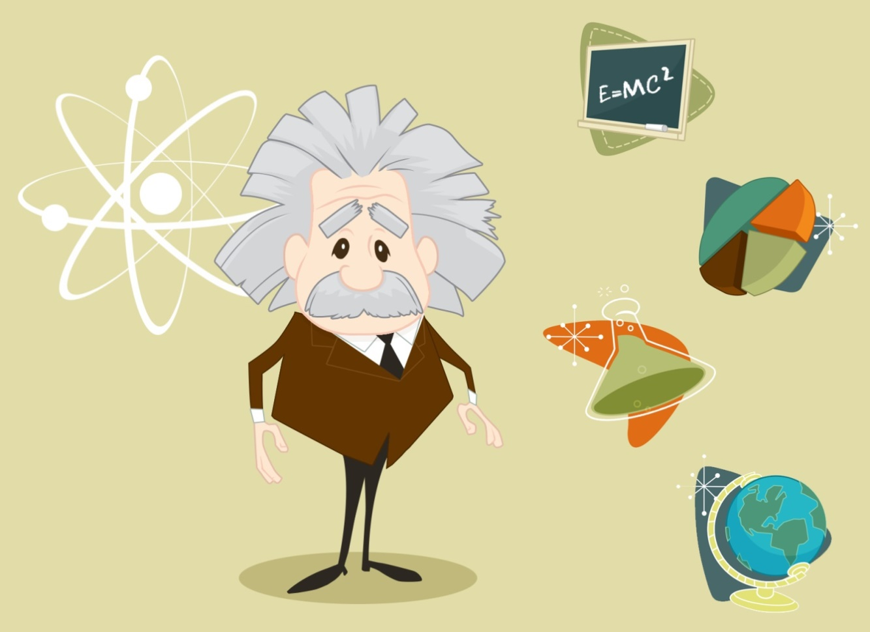

# Interface Design

The interface of this game will have a colorful mid-century style, what is sometimes referred to as “googie” designs. Lots of rounded edges, and atomic age shapes. We will be incorporating the classic design of yesteryear with modern flare. (See icon image below)

## Icons and Buttons

Very much like the rest of the interface, the icons and buttons in this game will have the same mid-century style, Lots of rounded edges, and atomic age shapes. Below is an example of the overall style we’d like to achieve.

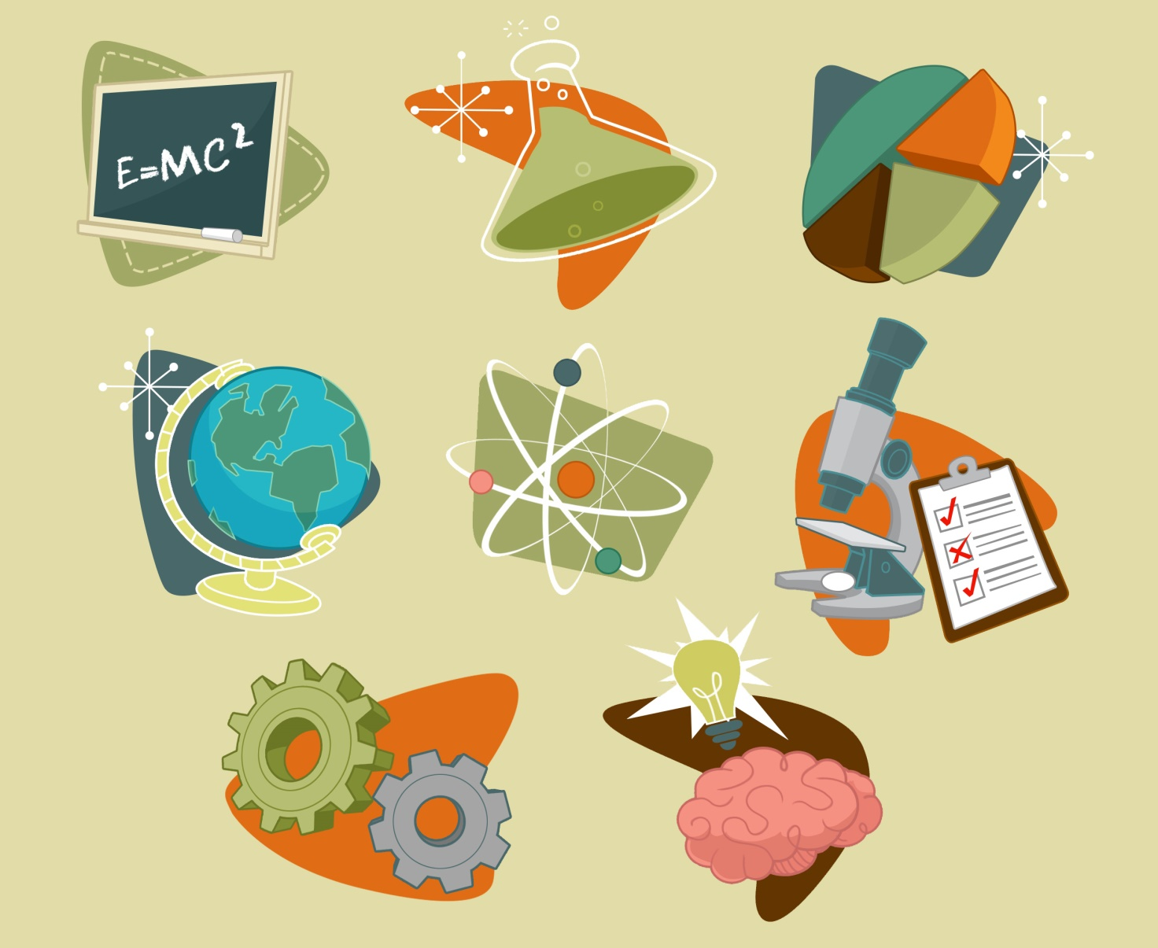

## Games and Apps

The games and apps will continue the styles present with the rest of the app, but also include exciting things like robots, rocket ships and scientific adventures!   
  
Below is a preliminary design example of a game in which planets are measured by mass.

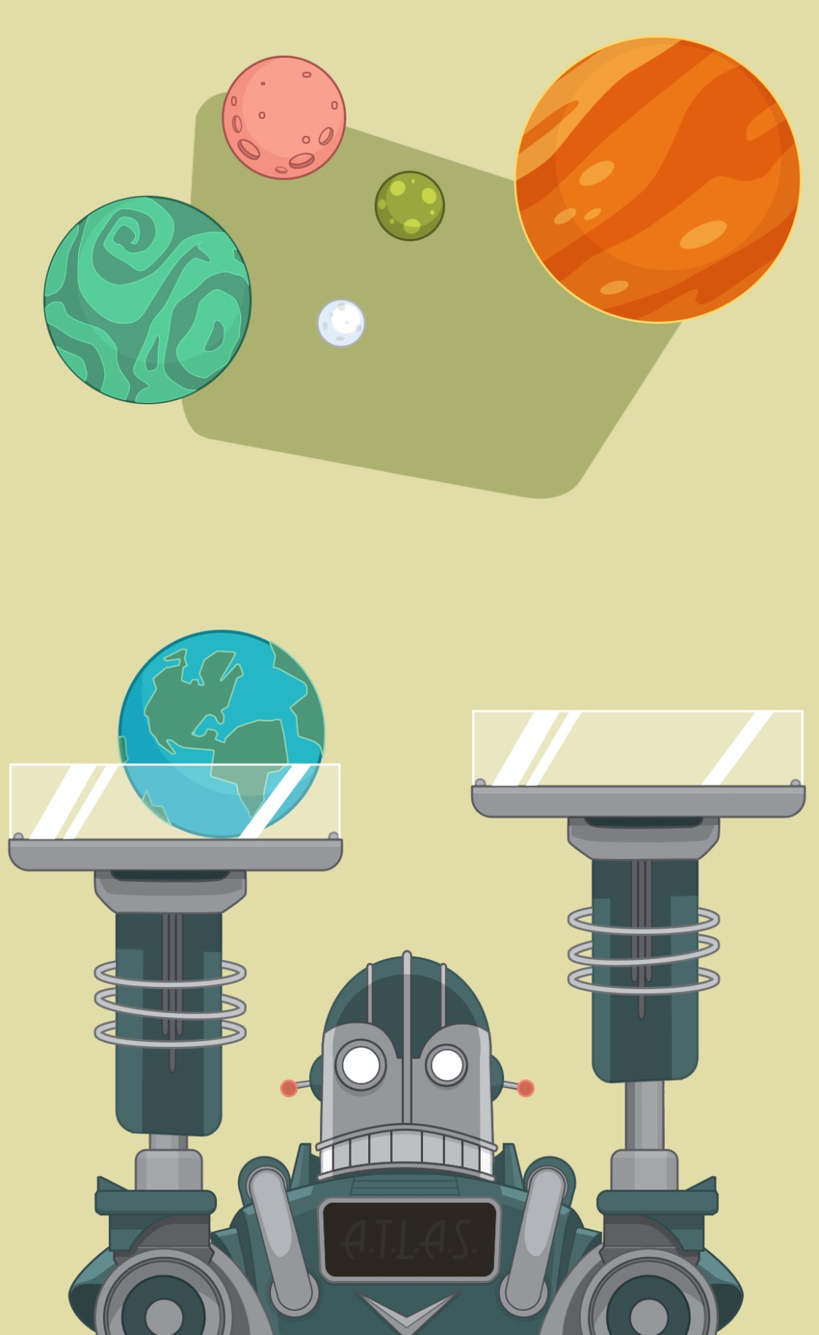

Below are two preliminary designs for the “PI Chart” portion of the app. We would like the chart to feel 3D but within the style language.

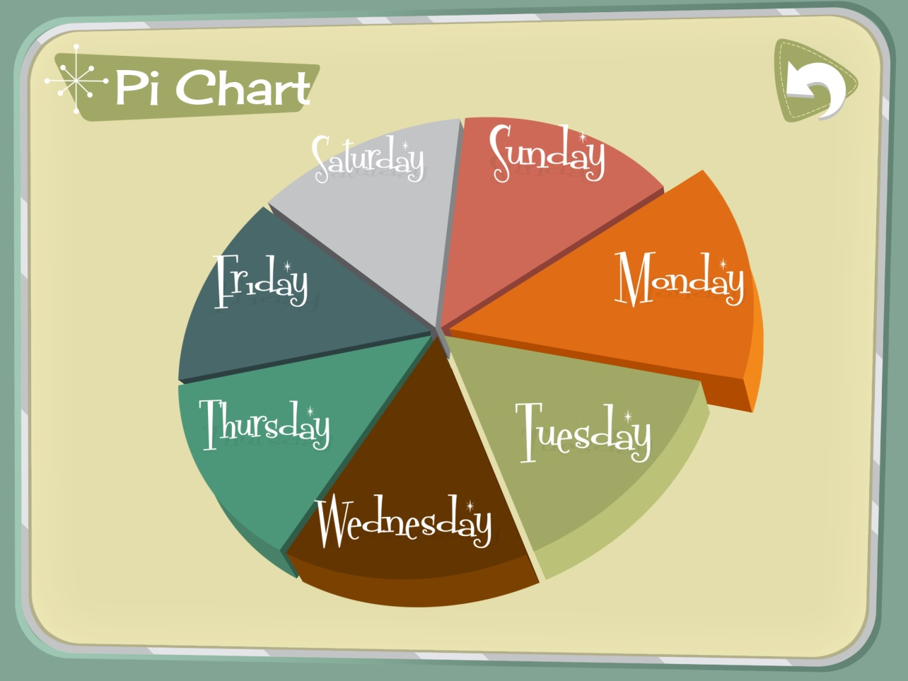

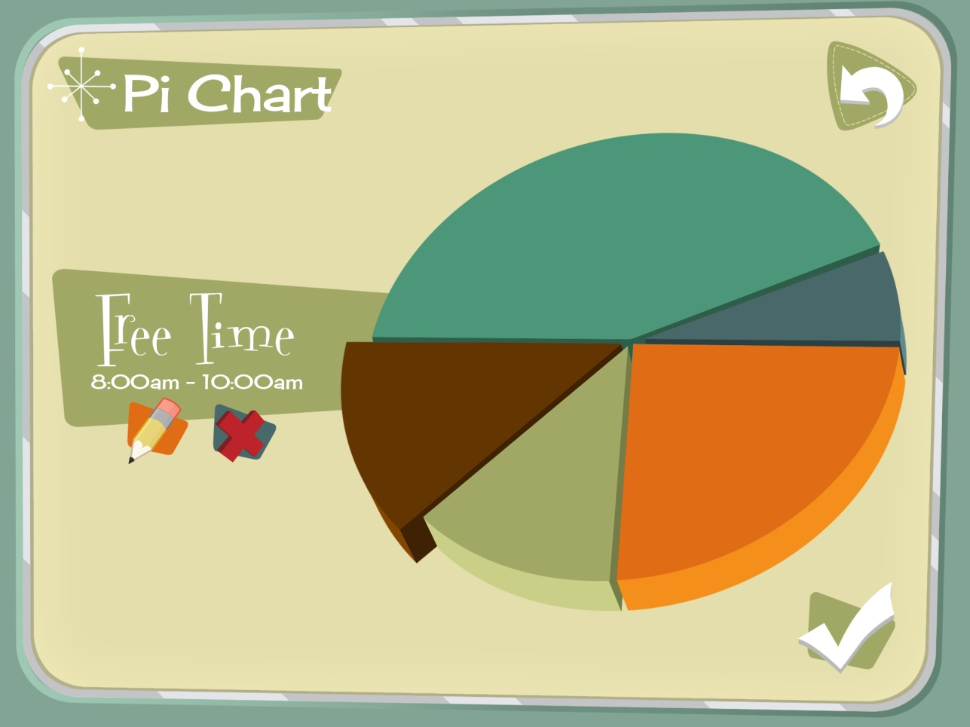

Below is a preliminary concept of the ‘MagNEATO’ game in which the user uses magnets to clear stars.

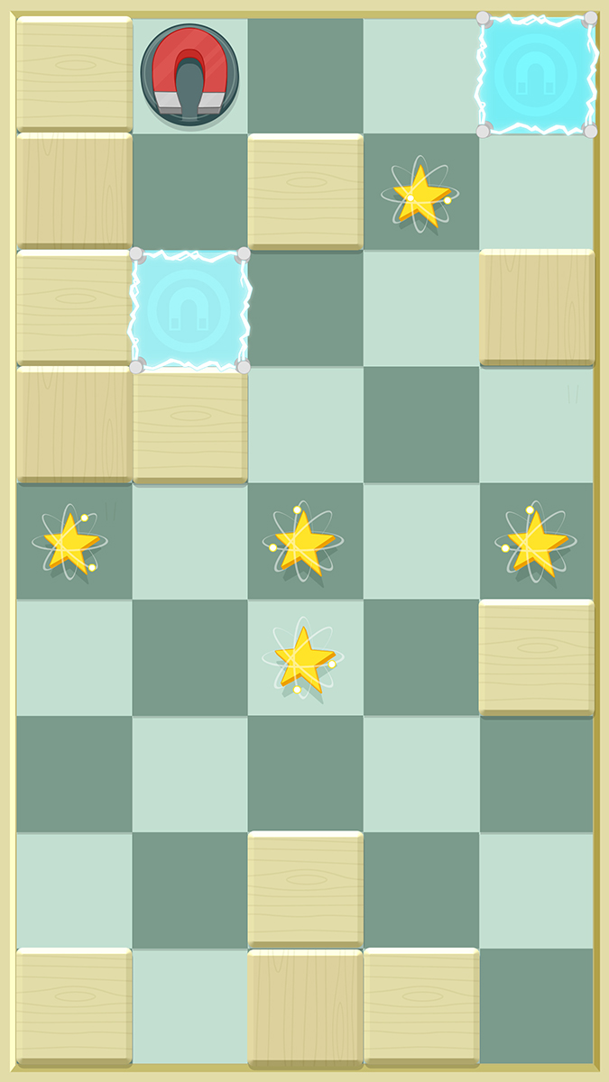

## Fonts

Fonts used in this game will be clear and legible fonts in the base; however for main headlines or titles, we will use any number of mid-century looking fonts, like the ones shown below.

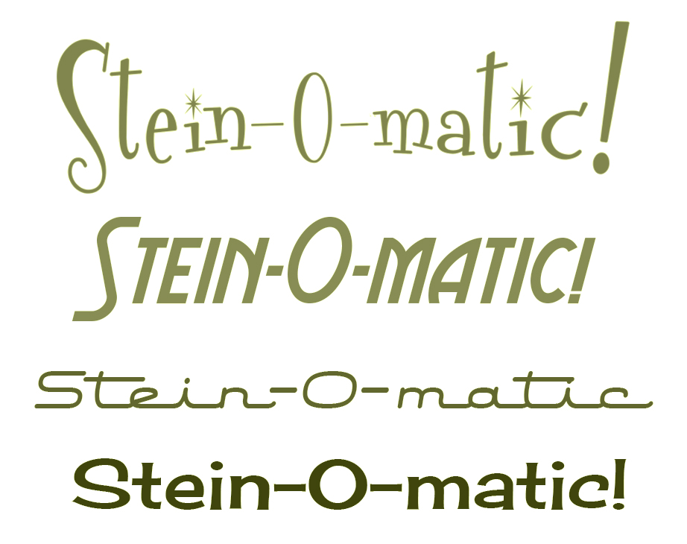

Fonts shown are:

1. Font Diner Regular
2. Aerovias Brasil NF Regular
3. Air Conditioner Regular
4. Cherry Cream Soda Regular

# Color Scheme

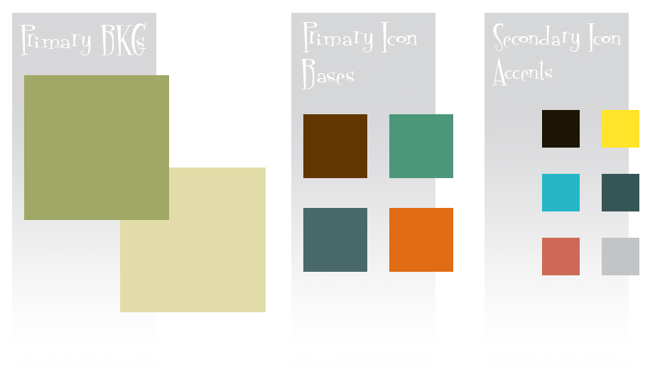

Colors overall will be mostly muted secondary colors. Primary colors can be used, but moved slightly over toward secondary colors. Color scheme should be vibrant but reflect a sense of nostalgia and classic cartoons and advertising.

# Form Language

Iconography used behind interface icons and throughout should be some form of these shapes. Rounded edges and free flowing. They can be used behind icons, containers for text and banner throughout.

\

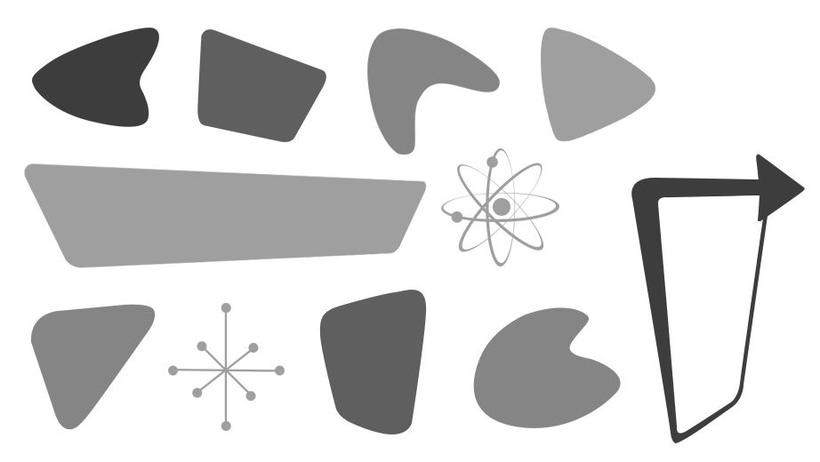

Even arrows in app should have the skewed, nonsymmetrical slant and rounded edges.

# Misc.

TBD